High Cycle Fatigue and Fatigue Crack Growth

Materials Lab 11

Luke Bury

Lgb544

**1) ___________________________________________________________________________________**

a) Stress Amplitude = 1.4850e+04 psi

b)

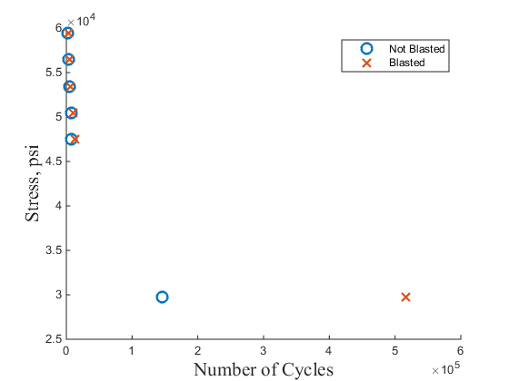

c) $σ_{a}N_{f}^{c}=b$

Not Sand-blasted: c =0.1721  
 b = 2.2962e+05

Sand-blasted: c = 0.1362  
 b = 1.7683e+05

*assuming sigma-fat = 0 psi, because no shift was needed for the fit





d) 4.9502e+04 psi

**2)___________________________________________________________________________________**

a) The failure most likely initiates at the location of the highest shear stress, which is at the root of the wing.

b)

c)

**3) ___________________________________________________________________________________**

a)



b)

|  |  |  |  |  |  |  |  |  |
| --- | --- | --- | --- | --- | --- | --- | --- | --- |
| **a** | 1.25 | 1.375 | 1.5 | 1.625 | 1.75 | 1.875 | 2 | 2.125 |
| **da/dN** | 8.11e-05 | 1.04e-04 | 1.79e-04 | 2.72e-04 | 4.31e-04 | 1.14e-03 | 4.17e-03 | 4.17e-03 |

c)

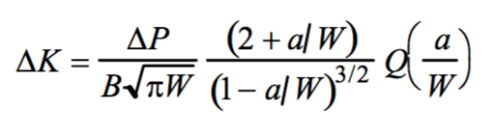

|  |  |  |  |  |  |  |  |  |
| --- | --- | --- | --- | --- | --- | --- | --- | --- |
| a | 1.25 | 1.375 | 1.5 | 1.625 | 1.75 | 1.875 | 2 | 2.125 |
| a/w | 0.3846 | 0.4231 | 0.4615 | 0.5000 | 0.5385 | 0.5769 | 0.6154 | 0.6538 |
| Q(a/w) | 1.8750 | 1.7890 | 1.7120 | 1.6340 | 1.5670 | 1.5000 | 1.4430 | 1.4010 |
| ΔK | 1.1593e04 | 1.2382e04 | 1.3350e04 | 1.4462e04 | 1.5879e04 | 1.7582e04 | 1.9804e04 | 2.2851e04 |

d)



e)



m = 7.1553

c = 5.3442e-34

**4) ___________________________________________________________________________________**

**5) ___________________________________________________________________________________**

a)

b)